The Bloodline of Shadows

Arshita

This is a work of fiction. Names, characters, places, and incidents are either products of the author’s imagination or used fictitiously. Any resemblance to actual persons, living or dead, events, or locations is purely coincidental.

1-The House They Called Home
2-The Descent of Tara
3-The Vanishing Wife
4-Two year later- The Visitors
5-Basement Whispers
6-The Morning That Never Came
7-The Red Room
8-The Girl in the Coffin
- The Diary's Truth truths
9-What Ella Hide
10-Ella – The Mother of the Curse
11-The Return to Her Mother’s Grave
12-The Diary Was Never Meant to Be Opened
13-Ella past
- The Murder of the Mother-in-Law
- The Final Revelation
14-The Whispering Well
- The Spirit of Padma
- Padma's Revelation
- Sara and Tara faith
15-The Blood That Built the House
- The Resurrection Begins
- The Real Bloodline
16-The choice
17-The House bleeds
- The Road That Isn’t
- The escape
18-The Road to Kaala Kherva
19-Kaala Kherva
- Old Secrets, New Wounds
- The Curse Within
- The Living and the Dead
20-Blood Never Lies
- The Curse of Ruhanika
21-The Price of Truth
22-The Final Rites
- The Return to Pari Cottage
- Nothing Left to Save
- Ghosts of the Living

Thankyou

Chapter 1
The House They Called Home

Sarah and Tara, two sisters with a quiet childhood, lived with their widowed mother, Ella. After the tragic death of their father, Ella worked tirelessly—not as a teacher but by giving tuitions and running small businesses from home. She was determined to build a brighter future for her daughters. For years, they lived in a small, rented apartment until one day, Ella finally managed to buy her own house—Meher Cottage.

It was old but large, located in a remote area with fewer neighbors, where hardly any vehicles passed. The house had four rooms—one for Sarah, one for Tara, one for guests and one for Ella herself. It had a spacious hall, kitchen and a mysterious basement that had always been locked.
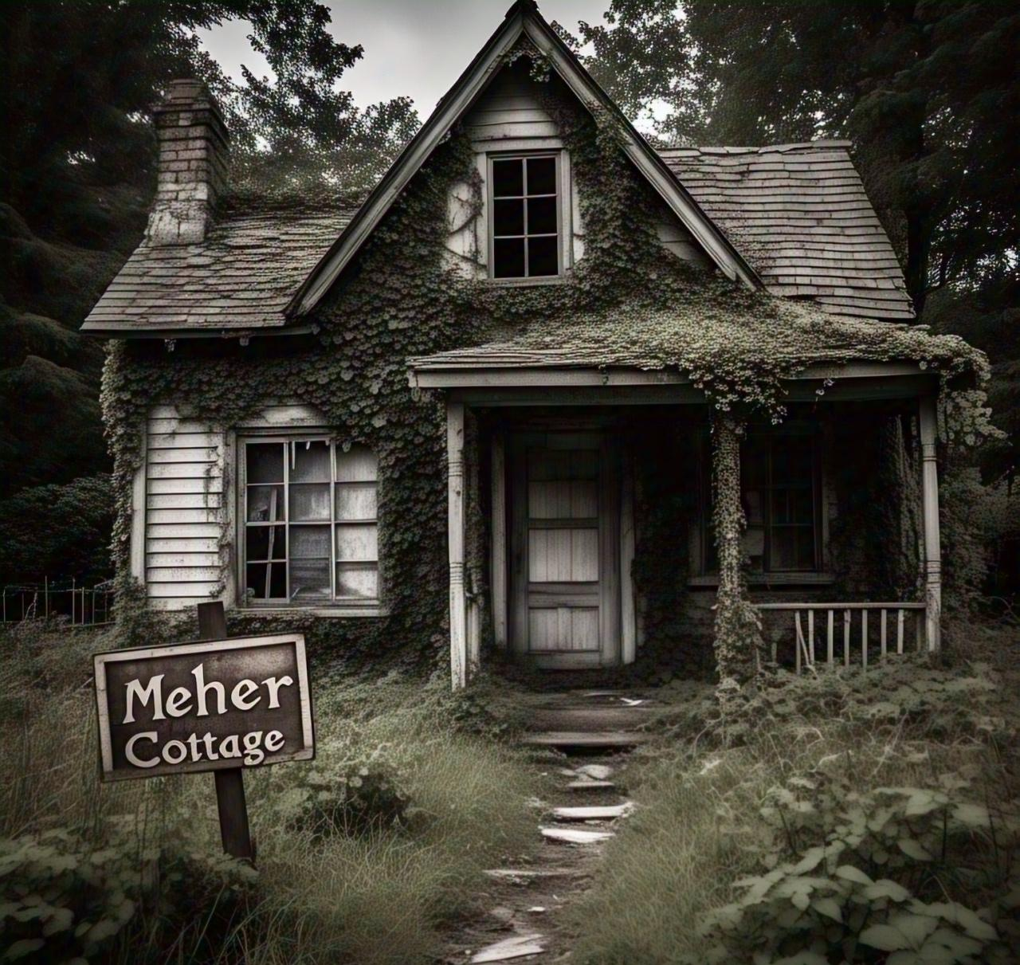
At first, everything seemed fine. But within weeks of moving in, Tara began acting strangely. She would smile at the walls, whisper to herself and stay up staring into corners for hours. Her skin turned pale, and her eyes darkened. Her body would swell unnaturally and then shrink again—like she was morphing.

Ella grew worried. Her business started failing because her focus shifted to her daughters. One night, Sarah approached Ella, her face pale and trembling.

“Mom... the basement... something’s wrong,” she whispered.

She described how one afternoon, she and Tara had gone down to clean the basement. While sweeping dust from the walls, a section of the bricks moved. Behind it was a small stone room. In the center was an old coffin sealed with rusted locks. Tara, curious and laughing, broke it open.

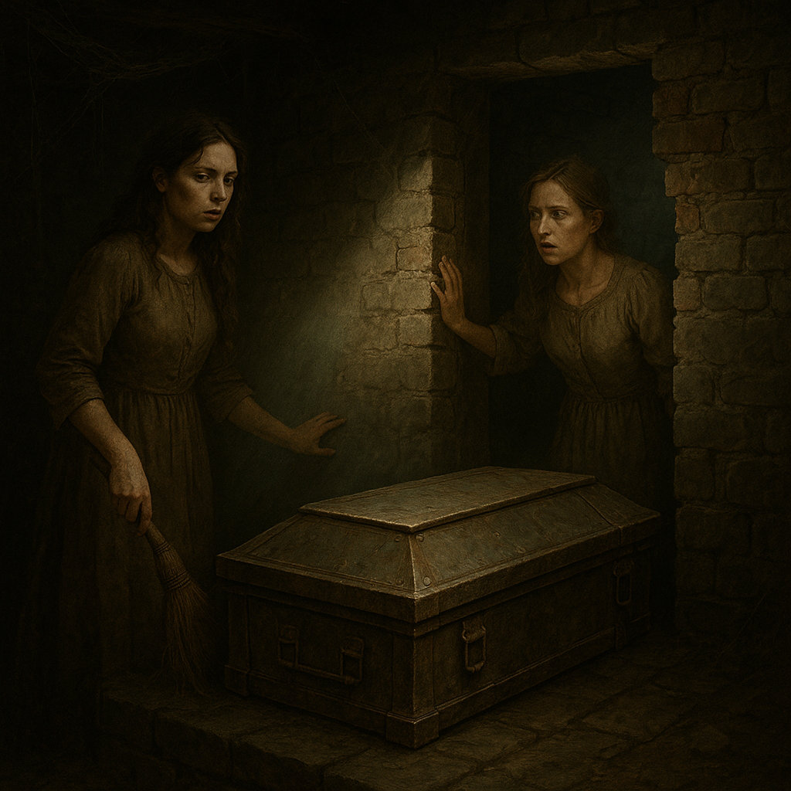

Inside, they found a diary wrapped in decaying velvet. It stank of blood and rot. Alongside it were wax dolls pierced with rusted needles, each labeled with strange names. Tara took the diary and dolls to her room—saying she “loved them.”

Since then, she had changed completely. And the house... never felt the same again.

Chapter 2
The Descent of Tara

Tara, who had once been cheerful and focused on her college dreams, withdrew from everyone. She stopped attending classes. She never came upstairs. Instead, she started living in the basement.

She painted symbols on the walls, spoke to shadows, and smiled at nothing. She wasn’t violent but she wasn’t normal either. She began scratching her own arms. She stopped responding to her mother and sister. Ella tried to help her, but every time she approached the basement, Tara screamed and pushed her away.

“You don’t belong here,” Sarah growled once, her voice echoing unnaturally.

Soon, Sarah started mimicking Tara’s behavior—laughing alone, disappearing for hours, even scratching the same symbols into her walls.

One night, Ella opened a drawer in Sarah’s room and discovered something horrifying.A tile beneath the drawer was loose. Beneath it was a second smaller coffin, and inside it was a corpse. The corpse of a beautiful girl, perfectly preserved, with a stitched mouth and empty eye sockets. In her arms was another diary—bloodier, darker.

Chapter 3
The Vanishing Wife

Years later, a young couple, Anjali and Raghav, were traveling late at night when their car broke down near the forest. The engine failed without explanation. Raghav stepped out to check but when he opened the bonnet, the car suddenly turned back on—without the key.

Lost and frightened, they found Meher Cottage. Ella, now frail and nearly unrecognizable, answered the door. Her skin hung loosely on her bones, her hair was thin, and she looked like she was 90, though she was barely 50.

“Please come in… my daughters will take care of you.She said, with an unnatural smile.She gave the Sarah room to Raghav and Anjali .

That night, everything changed.
As he opened his eyes, panic took hold.This wasn’t their room.

The walls were covered in damp, cracked wallpaper and cobwebs clung to the ceiling like veins. The bed beneath him was broken, its mattress sunken and moldy. Red, blood-like stains leaked down the walls, trailing like tears from invisible eyes.
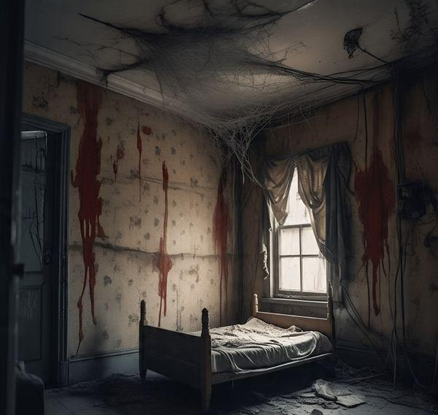
“Anjali?” he called out, his voice cracking.
Silence.

He stood up, trembling, and opened the door—only to find himself back in their original room. But it had changed.

The bed was empty.

A torn piece of Anjali’s dress lay on the floor.

And on the nightstand: a wax doll.

Its face was contorted, its body pierced with rusty pins, and on its forehead, a single word carved deep— “Anjali.”

Raghav searched the house, the garden, even outside—but there was no sign of his wife. Not a scream, not a trail. Days turned to weeks. He alerted the police, but they found the house abandoned—no Ella, no girls, no trace of human life.

Raghav never found his wife. But one night in his dreams, he saw her… lying in the basement, eyes open, with her lips stitched shut, whispering: "I shouldn't have stayed."

Chapter 4
Two year later- The Visitors

Two years had passed since the mysterious disappearance of Anjali . The case went cold. Locals avoided the Meher Cottage, whispering stories about “a mother who never left” and “daughters who never aged.”

One evening, a group of five college students—Shivani, Rohini, Natik, Nikhil, and Tanya—were returning from a hiking trip. Their GPS showed they were near a small village when their car suddenly stalled right outside a decaying property. The road had fogged up strangely, and their phones had no signal.“There’s a house ahead,” said Zaid. “Maybe someone there can help.”
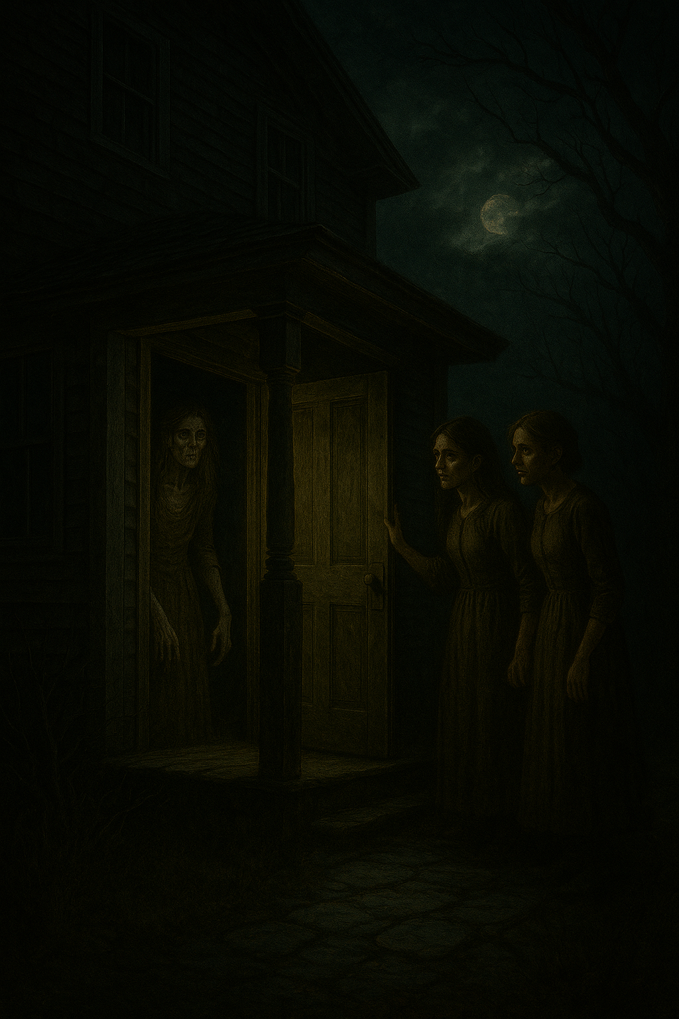

As they knocked on the gate, it creaked open on its own. They hesitated, but a soft voice called from within.

“You can stay here tonight… the forest is dangerous after dark.”

It was Ella.She looked too old—like her soul had aged faster than her body. She smiled, her lips trembling.

“My daughters would love the company.”

She led Shivani and Rohini to Sarah and Tara’s old room. The boys were given the guest room. Tanya decided to sleep on the couch in the hall, creeped out by the strange atmosphere.

That night, something was horribly wrong.

Chapter 5
Basement Whispers

At exactly 3:03 AM, Shivani woke up. Rohini was sleep-talking, whispering the word “basement… diary… play with me.”

Shivani sat up and saw that her friend’s eyes were wide open—unblinking. Terrified, she tried waking her but Rohini stood up on her own, grabbed a candle and walked straight out the room… towards the basement door.

Shivani followed, trembling. The basement was colder than death. The smell of rotting meat hit her nose the moment she stepped down. The walls were covered in old symbols drawn in what looked like dry blood.

Rohini was standing in front of an open coffin, her arms outstretched. Inside it was a wax doll… that looked just like her.

Suddenly, Shivani screamed.Rohini turned—her face pale, her eyes pitch black.
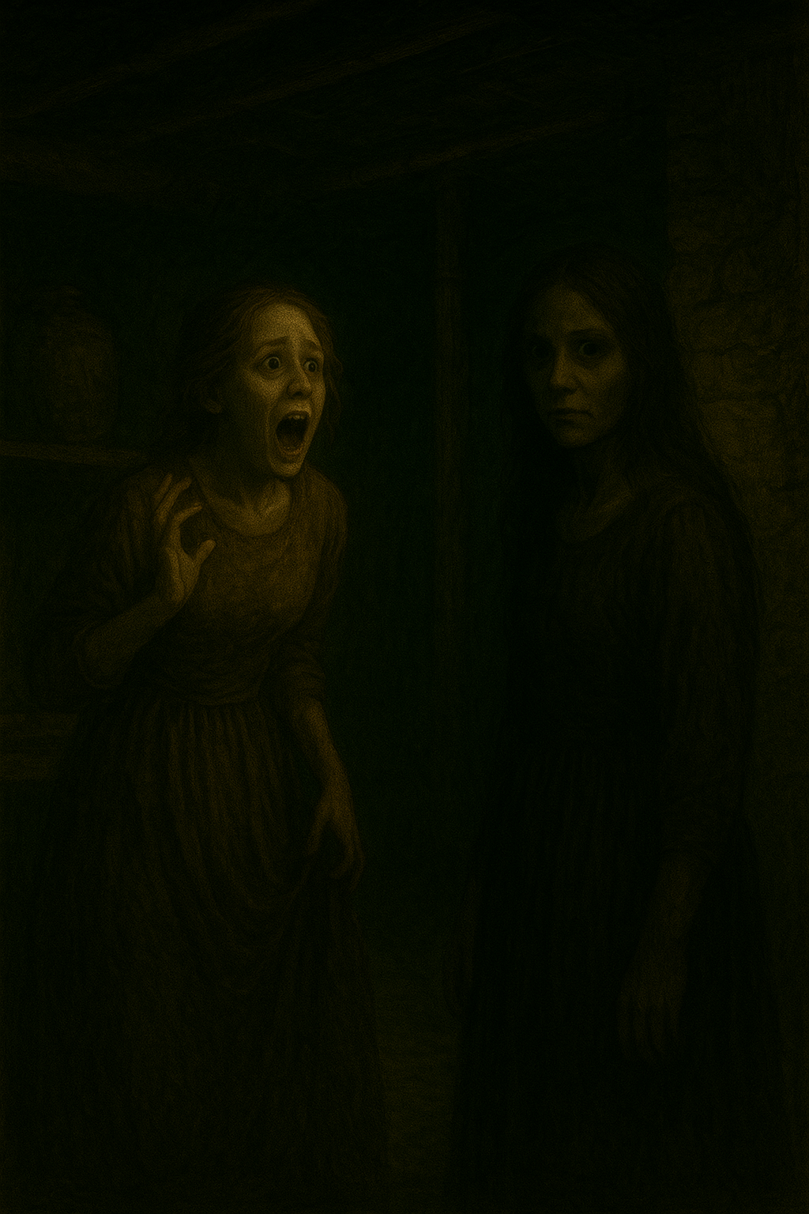

“Sarah says we can stay here forever.”

Chapter 6
The Morning That Never Came

The next morning, the boys woke up in a different house.The guest room they had slept in was destroyed, the furniture broken, the walls covered in spider webs, and blood handprints smeared on the door.

When they rushed to find the girls, they realized something horrible: Shivani and Rohini were gone. So was Tanya.

The hall was empty.

The entire cottage looked abandoned—as if no one had lived there for decades.
But the boys found one thing: a blood-stained diary in the garden, half-buried near a tree. It had names scribbled inside.Shivani,Rohini, Tanya, Anjali and more.Some names were crossed out. Some were still fresh.
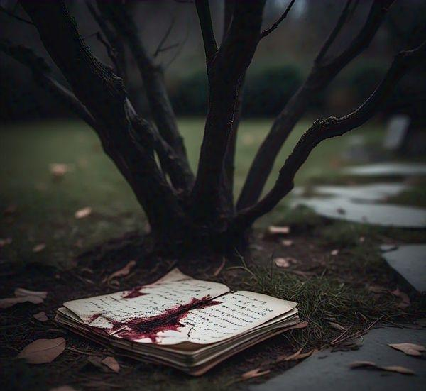

As Natik flipped to the last page, it simply read:
“New guests are always welcome. But once you're part of the cottage, you never leave.”

They ran.But the car that had refused to start two years ago. It worked perfectly now.

Chapter 7
The Red Room

Darkness.
That’s all they remembered.

Shivani, Rohini, and Tanya woke up together—lying on a cold, damp floor. Their clothes were dirty, skin pale and every breath they took reeked of iron and rot.

“W-where are we?” Tanya whispered, her voice shaking.

There was no answer. Only the sound of dripping… somewhere in the darkness.

As their eyes adjusted, they realized—They were in a room. Pitch black,Silent, Locked.

Then… a click.A door creaked open on its own.

And behind it—RED.

The corridor outside was completely soaked in red light. The walls oozed like they were bleeding. Strange dolls hung from the ceiling, each one stitched crudely, their heads tilted, their mouths sewn shut.
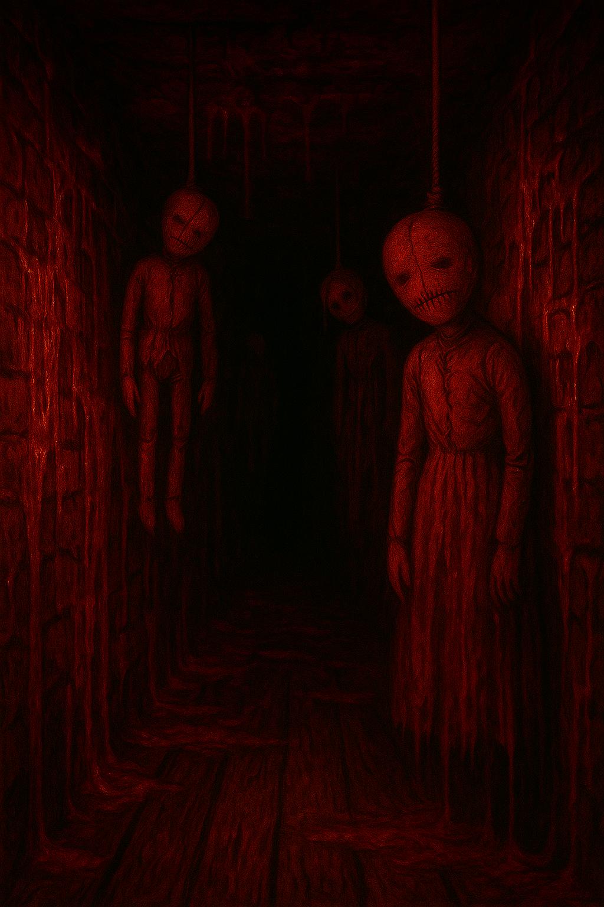

The smell of blood was unbearable.Tanya vomited. Rohini began to sob.
Shivani tried to be brave—but her knees gave out.We have to get out of here… now.

They held hands and stepped out—but as soon as their feet hit the red floor, all the dolls began to swing.

Back and forth.
Back and forth.
In rhythm.

Creak… creak… creak…

Then—a scream.

A loud, shrill cry echoed from behind them.They froze.It wasn’t human.
It was a child. A girl. Crying.

And then, they heard her—

Where are my sisters?
Why did they leave me?
Will you play with me now?

They turned slowly.And there she was.

A small girl in a white dress, soaked in blood, standing at the end of the corridor. Her face was hidden behind long, wet hair. She was dragging a broken doll in one hand. Her other hand covered in fresh cuts.

Suddenly, the walls started to close in.

The red corridor shrank, the dolls dropped to the floor one by one—crawling, twitching, laughing.

Shivani screamed.Tanya fell.Rohini turned back—the door had vanished.
Now, the only way forward… was toward the crying girl.And as they stepped closer, they realized…She wasn’t crying anymore. AaShe was smiling.

With teeth too sharp for a child.
The girl in the blood-soaked dress smiled wider, tilting her head slowly as if studying the girls.
Shivani, Rohini, and Tanya stood frozen. The air was thick with rot, and the sound of dolls giggling softly surrounded them.

“W-What do you want?” Shivani whispered.

The little girl dragged her doll closer, leaving a smear of blood behind her.

“Play with me…
Die with me.
Stay forever.”

Suddenly, the lights flickered. The red hue vanished and the hallway turned pitch dark again. Only the girl's glowing white eyes remained, staring at them like two open graves.

Rohini screamed and ran down the corridor—but the hallway twisted. No matter where she turned, the girl was always ahead, waiting.

Tanya backed into a wall. Something cold wrapped around her ankle—a doll’s hand, twitching.

Shivani, trying to stay calm, looked into the child’s face—then realized it wasn’t a child at all.

It was a doll come to life, sewn with pieces of different children’s faces, lips stitched with human hair, and the dress—Ella’s old white gown—torn and soaked with Sara’s blood.

“Your hearts still beat,” the doll-girl whispered.
“Let me silence them.”

Suddenly, the walls burst open with screams. The girls fell backward.

Chapter 8
The Girl in the Coffin

A week after Nikhil and Natik escaped, they returned with police and a local news crew. But when they reached the address—there was nothing.

No cottage.Just a vast stretch of forest.
But Natik had kept the diary they found. The pages had changed. New names were now faded, as if something had erased them. But one name remained, circled over and over: Ruhani
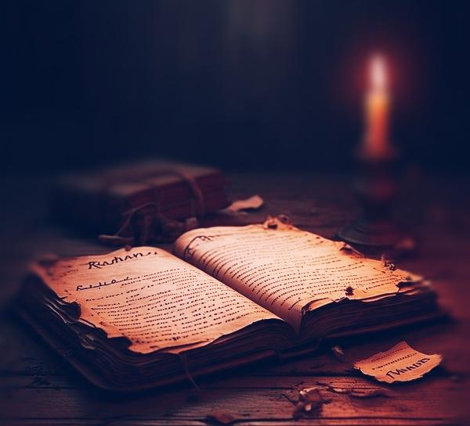

They took the diary to a priest in a nearby village. The priest was silent for minutes after opening it. Then he whispered:

“This... this is not a diary. It’s a binding ritual. A soul trap.”

He explained that-Ruhanika was a girl who lived 80 years ago, known for her strange abilities—talking to shadows, controlling dreams, and causing people to forget they ever existed. She was buried alive by villagers in a coffin layered with black salt and iron, bound by spells to never let her spirit escape.
But she had one daughter.

The Diary's Truth

In the deeper pages of the diary, written in blood, were confessions—not from Ruhani, but from Sarah.

“I saw her. She asked me to take the doll. I didn’t want to. But Tara forced me to. She said the doll was her friend.”
Another page:
“I didn’t sleep last night. The doll whispers. It tells me how I’ll die. And then it laughs.”
And the most chilling entry:“Tara stabbed me with the needle”. Right in the back. She said I’m not her sister anymore. She said... I’m the doll now.

Sarah’s handwriting changed—became childish, erratic. Some pages were just symbols, scratches, and numbers repeating: 3:03... 3:03... 3:03...
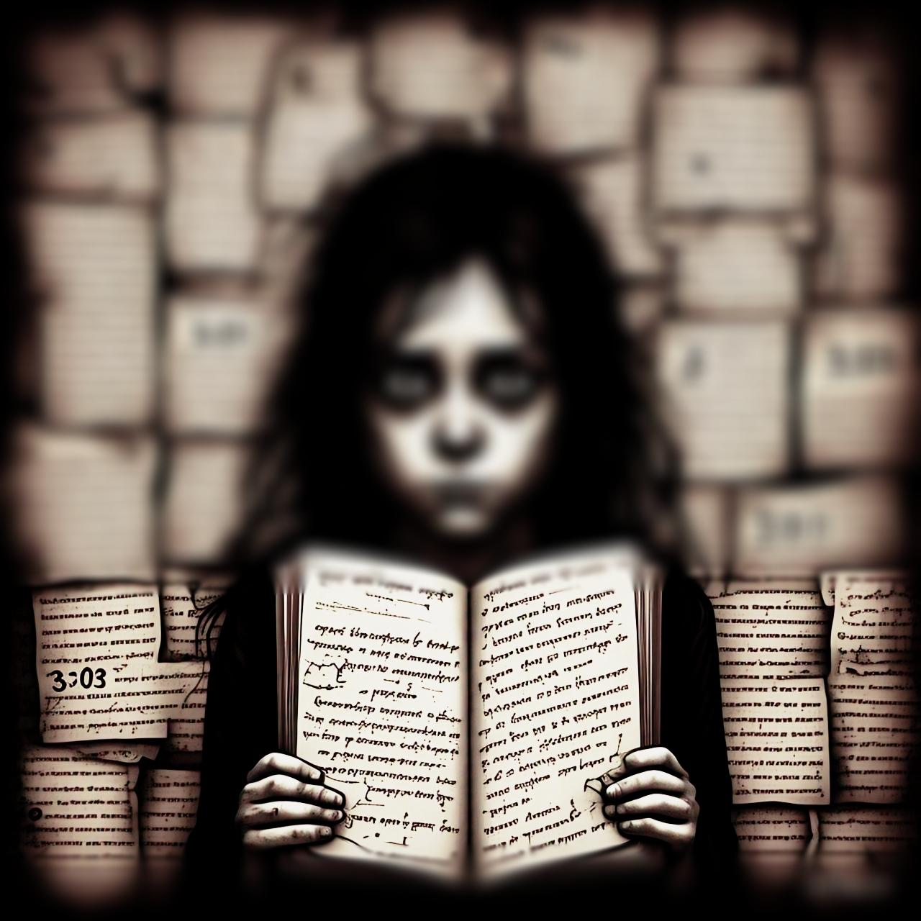
That was the exact time Rohini had walked into the basement.

Chapter 9
What Ella Hide

The next revelation came when Natik returned alone to Meher cottage with a tracker drone. He found a deep pit near the location of the old cottage. When he descended with ropes, he found something horrifying: A second coffin, nailed shut. On the lid: “ELLA”.

But inside?Not Ella.

It was filled with burned dolls. Each one labeled. Rohini, Shivani, Tanya, Anjali More. All with needles pinned in their chests.
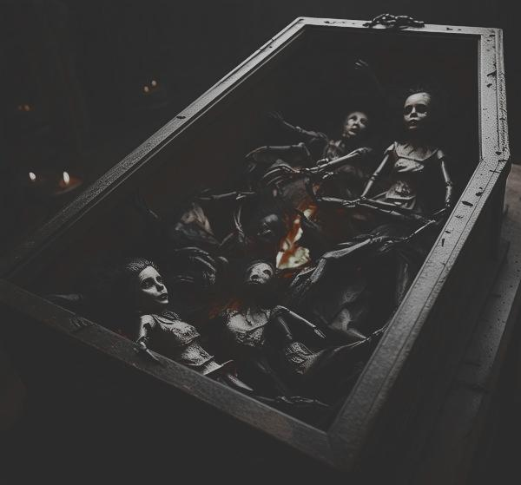
But something was watching him from the shadows. He heard whispers... "Don’t take the diary.You’ve been marked."
Natik escaped. Barely.

When he checked the drone footage the next day, the basement door could be seen in one frame. Standing at it: a girl with black eyes, a cracked face like porcelain... Sarah.

But she wasn't moving. Just watching.

Chapter 10
Ella – The Mother of the Curse

Long before Ella moved into Meher Cottage with Sarah and Tara, she had a secret life she never spoke of—not to her daughters, not to anyone.

Ella wasn’t born in the city.

She was born in a village called Kaala Kherva, just 10 kilometers from the forest that now surrounds the ruins of Meher Cottage. Kaala Kherva was abandoned overnight in 1972 after a mass death of all children under 10. Rumors claimed they were victims of a woman named Ruhanika, a healer accused of witchcraft.

Ruhanika had no family. But some said she had a child, born in secret—never registered, never seen in daylight. Some said she passed her spirit into this child before being buried alive.

Ella was that child.#

Chapter 11
The Return to Her Mother’s Grave

Ella was adopted by a family in a nearby town. But her childhood was... strange. Animals avoided her. Mirrors cracked when she passed. She spoke to her toys like they were people. And her drawings always had a black figure standing behind her.

As an adult, she changed her name to Ella. She built a life, got married, had Sarah and Tara. Her husband thought she had nightmares—but Ella never dreamed. She always heard her.

“Come back to me, Elaara.”That was her real name Elaara.
Short for Elaara Ruhanika.

When she saw the house for sale notice in the forest, something pulled her there. She didn’t ask why it was so cheap. She didn’t ask why no one dared go inside.

She knew.

This was Ruhanika’s resting place,where she practices the black magic.

Chapter 12
The Diary Was Never Meant to Be Opened

Ella found the coffin first. Years before her daughters. She opened it and found the diary... but she couldn't read it. Every time she tried, her vision blurred, and she heard her mother whisper:

“Let me in, Elaara. I made this world for us. Your daughters will be safe here… forever.”

So she closed it. Hid it. Locked the basement. She made up stories—“It’s just storage,” “It’s dangerous down there.” But one day when she was away, Tara broke the lock, found the diary, and everything changed.

Ella watched her daughters fall apart—Sarah talking to the wall, Tara laughing alone in the basement. She tried to stop it. She even tried to burn the diary once.It wouldn't burn.It bled.

The next day, Sarah had blood under her nails.

She looked at her mother and said:
“You betrayed her, Mom. She knows. She’s coming.”

Ella stopped eating. She locked herself in her room. When she looked into the mirror, it wasn’t her face—it was Ruhanika’s.

She carved runes into the floor to protect her daughters. But they never worked. Not against her own blood.

Because Ruhanika’s soul was already inside her.And the diary was not a record.

It was a contract.

Chapter 13
Ella past

The hidden pages of Ella’s diary were stitched together—not with thread, but with human hair. When Natik finally peeled them apart, the truth bled through each word like an open wound.

The entry was dated seven years before Sarah and Tara were born.

“I was barren. No life grew in me.
But the doll said—‘Life takes life.’
And I believed her.”

Ella had been trying for years to become a mother. But the house—the cursed Meher Cottage—whispered a different method. One that demanded a trade.

So Ella stole a little girl.Her name was Meher. A silent girl who lived in the village. Ella brought her to the house .But Meher never left.

The Ritual:

Ella wrote every detail:

She drew a pentagram in the basement with Meher’s blood.
She stitched the girl’s name into a doll made of wax and human bone.
She carved a coffin small enough to trap a soul—and buried it alive.
And as Meher screamed inside the box, Ella chanted the final line:
“Let my womb be filled with what her heart carried.”
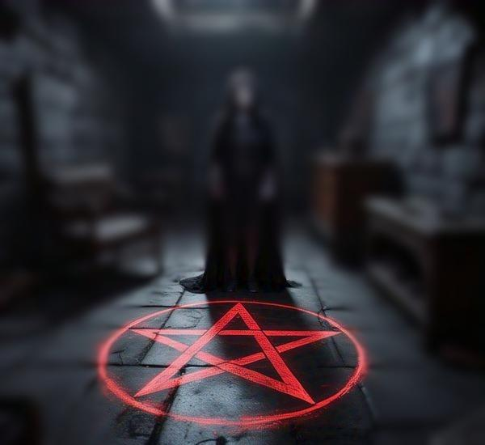
That night, Ella conceived her first child—Ruhani.But the baby was born and died after some years.

So, she placed Ruhani’s soul into the same doll. The doll that always sat in the basement. The one with stitched eyes and a mouth that sometimes moved.

The Murder of the Mother-in-Law

Only one person knew the truth.Ella’s mother-in-law, Padma.
She had once been a spiritual healer. She sensed the evil in the house—and the unnatural silence of the girl Meher, who "ran away" mysteriously.

Padma confronted Ella with a talisman one night, threatening to banish Ruhani’s soul and destroy the coffin.That same night, Padma disappeared.

Ella wrote the truth:
“I pushed her down the well.
She didn’t scream.
She smiled.
She said, ‘Your daughter will cost you everything.’
I sealed the well with prayer stones.
But I still hear her voice, calling my name from the dark.”
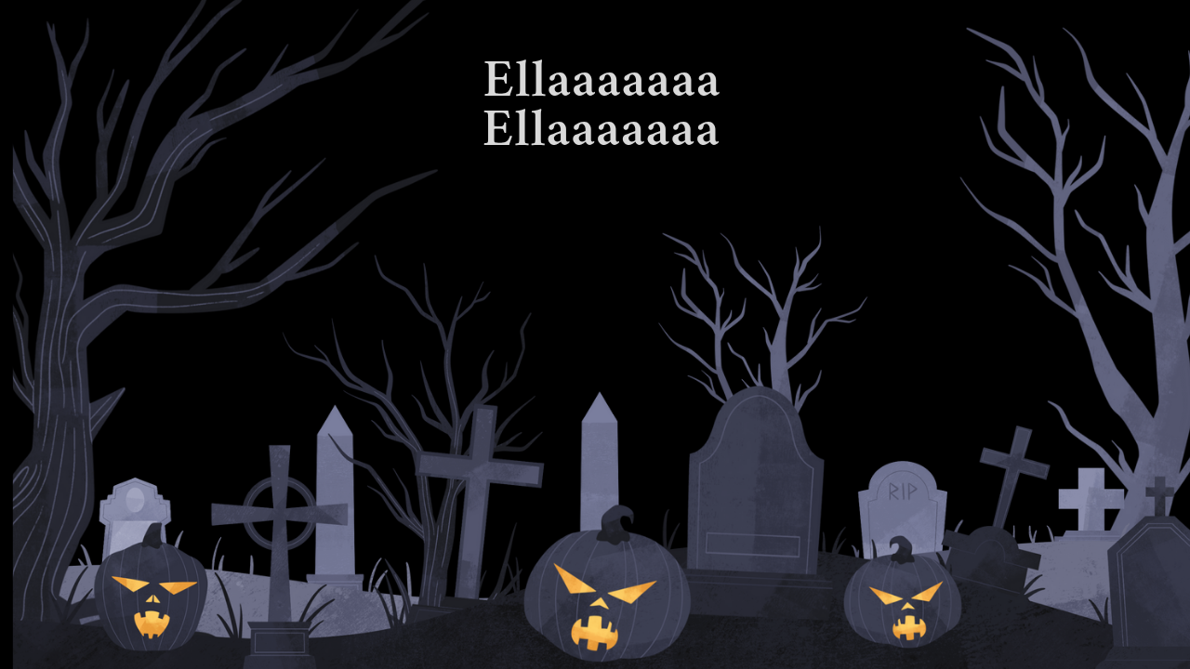

The Final Revelation

Natik dropped the diary.Because now… he could hear it too.

From the backyard of Pari Cottage…A soft, gurgling whisper from the sealed well.

“Ella…
She was never the mother”.

Chapter 14
The Whispering Well

Meher Cottage didn’t creak that night. It growled.

The trees leaned in, the wind curled backward, and Natik found himself standing at the old well—its stones cracked, its prayers broken, its silence disturbed.

“You shouldn’t be here…”
The voice didn’t come from outside.
It came from inside him.

And then—from the well—it answered.But he must know.

The Spirit of Padma

A mist rose from the mouth of the well, coiling into a shape. A woman in a red saree. Wet Hair hanging like roots. Wrists scarred. Eyes—open wide but empty.
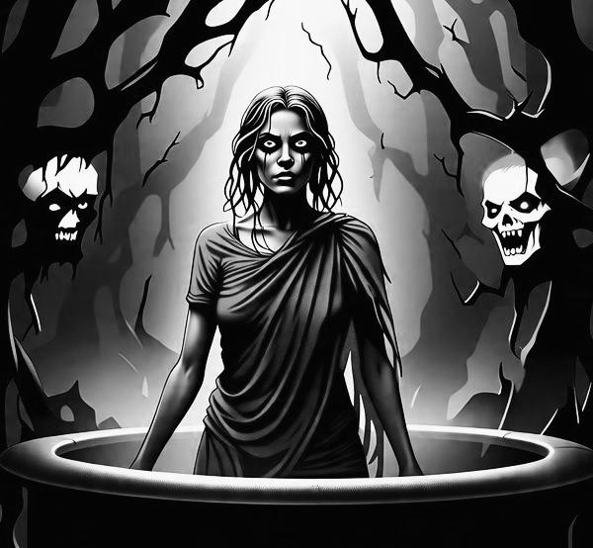

It was Padma.
“I am what she buried.
I am what she feared.
And now, I am what you must face.”

Natik stepped back. But the spirit didn't chase him.
She floated over the stones… and began to speak the truth.

Padma's Revelation

“Ruhani was never meant to live”.

Ella used blood to summon her.A ritual gone wrong.
She stole a child’s life to give herself one.

But the child—Meher—fought back… from the inside.”

The soul inside Ruhani was not pure.
It was fractured.
A blend of Ella’s cursed desires… and Meher’s pain.

That’s why Ruhani never smiled.
Why mirrors cracked around her.
Why the coffin followed her everywhere.
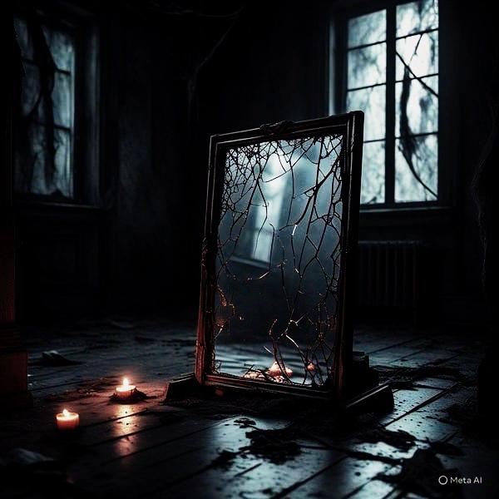

But the worst truth?
“Ruhani was never happy…
So ,she died.”

Sarah and Tara faith
“Tara wasn’t born evil.
Sarah wasn’t meant to change.
But when they entered Pari Cottage,
Ruhani’s soul—split between coffin and doll—entered them both.”

One took her anger.
One took her hunger.
And now, the real Ruhani is trying to come back—not alone, but in two bodies.

“She is stitching herself together.
With their flesh.”

Padma’s voice cracked.
The mist turned red.

“You must destroy the coffin.
Or bury the house.
Or they will be next.”

But Then… The Warning,As Natik turned to run, Padma screamed:

“WAIT—
Ella was never the mother.
She was the friend.
The real mother… is still below.
Sleeping.”

And from the depths of the well—A second voice.

Not Padma.Not Ruhani.

Older,Hungrier,Wiser.“Open it, boy.
I want to meet my daughters.”

Chapter 15
The Blood That Built the House

The house groaned with the weight of secrets.

Meher Cottage was more than walls and wood—it was a silent witness to centuries of pain and betrayal.

Natik stood in the basement, clutching the diary, heart pounding with a terrible truth.

“She was never the mother,” he whispered.
“She was the thief who stole someone else’s bloodline.”
The Resurrection Begins

Upstairs, Sarah screamed—a voice not her own twisting through the halls.
Tara whispered to empty walls, speaking not to Natik, but to her sister.

“You promised you wouldn’t leave me…”
Mirrors cracked simultaneously, sharp lines splitting their reflections.

From beneath Sarah’s bed, the wax doll stirred.Eyes blinking. Mouth opening.

“Let me in.”

The Real Bloodline

Natik’s hands trembled as he opened the ancient coffin.
Inside lay Ramika—still and serene, untouched by the darkness that had poisoned the house.

Then, like a whisper carried on the cold air, Ramika’s voice spoke to him—not with magic, but with the power of truth.
“I built this house. I loved this land. I loved my husband.”

“But Ella… she wanted it all.”

Natik froze.

“She desired my husband and waited for a moment of weakness.
When I fell ill during childbirth, she used black magic to take my place.
She never told anyone.”

Ramika’s voice trembled, not with fear—but with grief. “The girl in your mind—Meher—is not dangerous. She is my daughter.
But Ruhani… Ruhani is the child born through Ella’s black magic.
No prayer, no ritual can tie her down.”

“That wax coffin in Sarah’s room… I placed it there myself, long ago.
Not as a curse—but as a mother’s last tie to her child.
Ella never knew. She hadn't yet taken my place when I did it.”
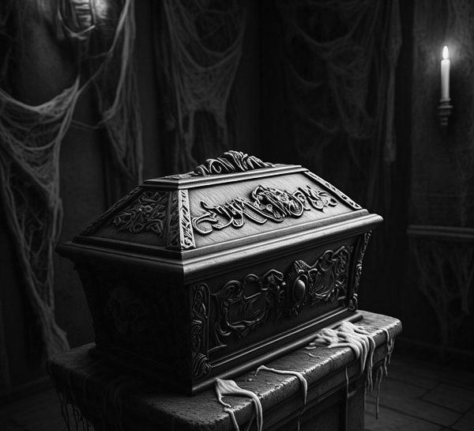

Natik's voice cracked:“Then how do I stop this?”

Ramika whispered:
“You don’t need to stop Meher.
You need to understand Ella.
And only one person alive knows the full truth.”

“Ruhani’s uncle—he lives in the old village, Kaala Kherva.
He saw what Ella did.
He was there the night she summoned Ruhani.”

Chapter 16
The Choice

Natik stood frozen in the doorway of the house.

The silence after the storm chilled him more than the screams ever had.

He remembered Padma’s words:

“If Ruhani merges with the girls completely, no one will be able to bring them back.”
But now, with Ramika’s truth echoing in his mind, everything had changed.

It wasn’t Meher who needed saving.It was Sarah and Tara.

And stopping Ruhani… would mean confronting Ella’s legacy.

He ran outside the well and back upstairs—to Sarah’s room.

The wax coffin was open now, lid pushed aside.The wax heart inside had cracked. A faint warmth still pulsed from it.
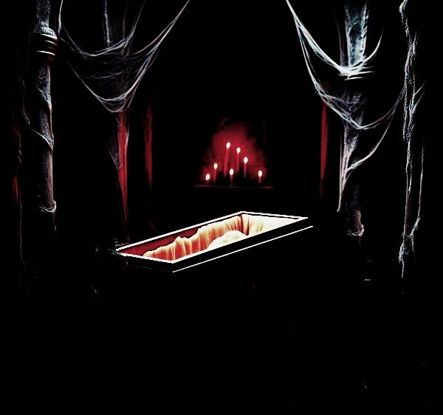

Natik reached out.But before his fingers could touch it—Two shadows appeared behind him.
Sara and Tara.

Standing side by side.One trembling, The other calm.Both too quiet.Their eyes… not black with possession,just blank,hollow.Tara whispered: “You said you’d help us…” “But it’s too late now.”

And together, a voice not their own echoed beneath theirs—softer than before, but still wrong.
“Ruhani is awake.”

Natik stepped back, eyes flicking between them and the broken coffin.He still had a chance.But he didn’t need to destroy the heart.He needed answers.

Ramika’s final words returned:

“Go to Kaala Kherva.
Find her uncle.
Before Ella finishes what she started.”

And Natik knew—The choice was no longer between burning a heart or saving a soul.It was between running from the truth or chasing it to the edge of the curse.

Chapter 17
The House Bleeds

The moment Natik stepped past the threshold of Meher Cottage, he felt it.
The shift.Like the air had thickened.
The trees no longer swayed. The wind no longer moved.
The ground beneath his feet was soft—not with mud, but with something older. Heavy with memory. The house had released its secrets, but the land was not ready to let him carry them away.

He tightened his grip on the diary, the locket he found near the wax heart, and the small cloth-wrapped box Ramika had begged him to take.
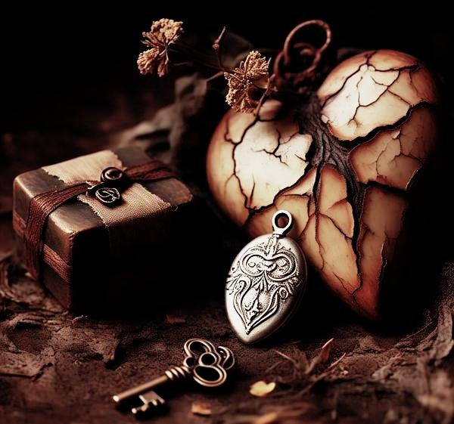
“Go to Kaala Karva,” she had said.
“Find the man who saw what Ella did.
He’s the only one who can stop Ruhani.”

The narrow path that led to the main road was barely visible now. Vines had slithered across it in a single night, thorns curving like claws.His phone had no signal.His bike wouldn’t start.Even the crows had gone silent.

As he walked further down the hill, he felt it more clearly—the land breathing behind him. Watching,Bleeding.

A small cut opened on his heel from a thorn. He ignored it.Another thorn scraped his arm then another.But it wasn’t the pain that scared him.It was the color of the blood.

Black, thick and slow.

As if the house had marked him.

“You carry her name,” a voice seemed to whisper from the trees.
“And she doesn’t like to be left behind.”
He didn’t look back.

The Road That Isn’t

The main road that once connected Meher Cottage to the outside world…

It was gone.

In its place—dense woods. As if the forest had never allowed a path through.
“This isn’t real,” Natik muttered.But it was.

The land was folding in on itself.Not magically,deliberately.Like it had been instructed long ago—no truth leaves this soil.

The Escape

He pushed open the cottage door. The morning light stung his eyes—it felt too clean for a place like this.

He ran toward the old path leading to the village road.But Ella was waiting.

She appeared from behind the well, her face as calm as stone, her long black braid coiled like a snake.
“You can’t leave,” she said quietly”.
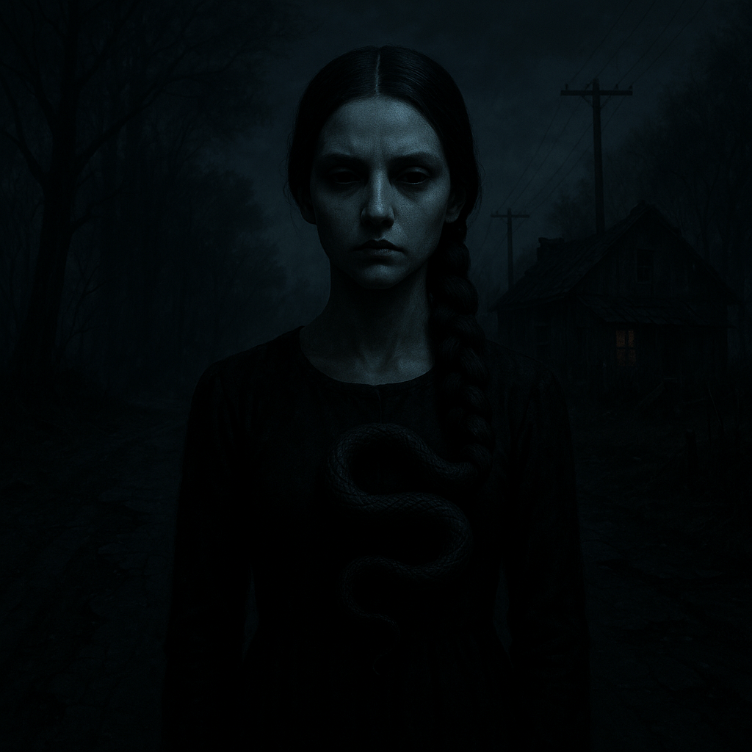

But Natik didn’t stop.He moved faster.Ella raised her hand.Whispers filled the air:black threads of smoke slithered from her fingers toward the path. The grass turned black. The wind screamed.

But nothing touched him.The black magic bent—then broke. Like an old spell unraveling in front of its maker.

Ramika’s diary glowed faintly in his bag.

A mother’s truth, stronger than a witch’s lie.Ella stepped back.Eyes wide.For the first time, she looked powerless.

The Road to Kaala Kherva

Natik didn’t look back. He ran until the road reappeared.Until the thorns disappeared.

Until the land stopped breathing down his neck.
He reached his bike.

It started on the first kick.

No thorns. No whispers. Just wind.

Meher Cottage vanished behind the trees as he rode fast—toward Kaala Karva.

Toward the man in the photo.Toward the final truth.

Chapter 19
Kaala Kherva
Kaala Karva looked like it hadn’t changed in fifty years.
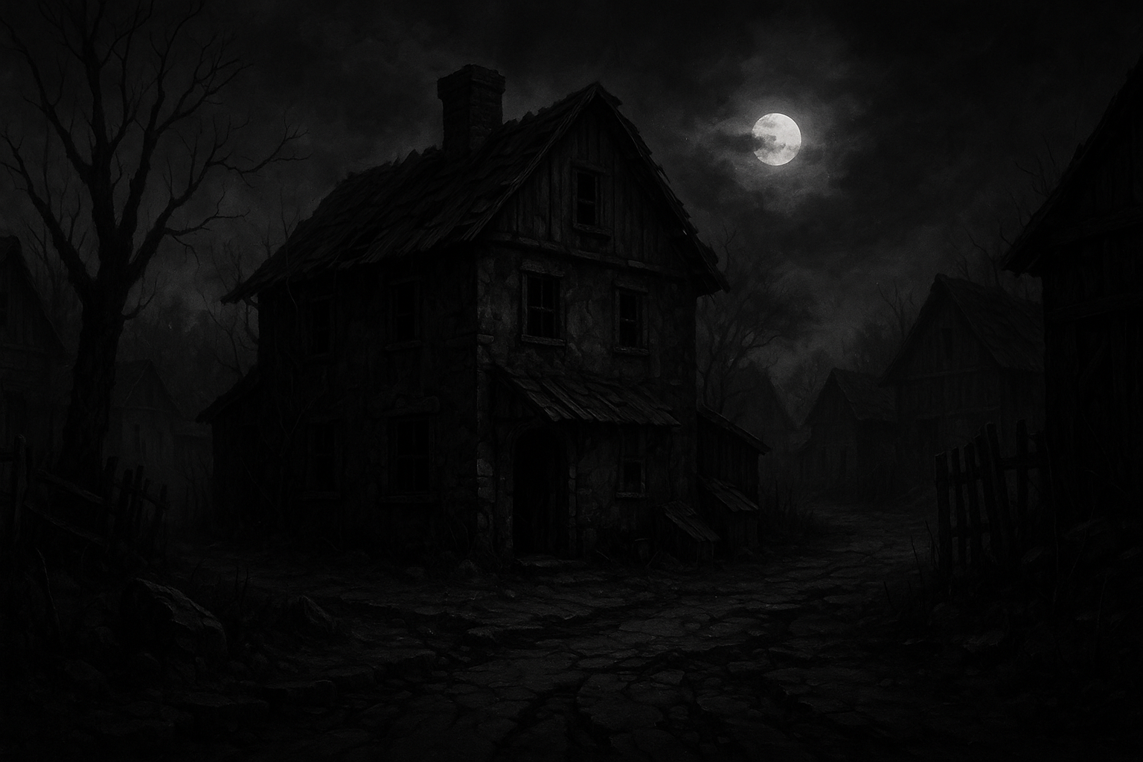

A forgotten village, where the silence was heavier than air, and memories walked the streets like ghosts.

Natik followed the narrow mud road past the temple ruins, holding Ramika’s diary and the photo from the locket. He reached a crumbling hut near the edge of the forest. The man in the photo lived here.

He knocked.The door opened slowly.

A man with silver hair and tired eyes stood there—Hariram.

He looked at Natik, then at the locket in his hand.

And without asking a question, he stepped aside.

“So… it’s finally time.”

Old Secrets, New Wounds

Inside, the room smelled of ash and herbs. Hariram lit a lamp and sat across from Natik.

“You’ve been to Meher Cottage, haven’t you?” he asked quietly.
“I have Ramika’s diary,” Natik replied. “I know about Ruhani. But not everything.”
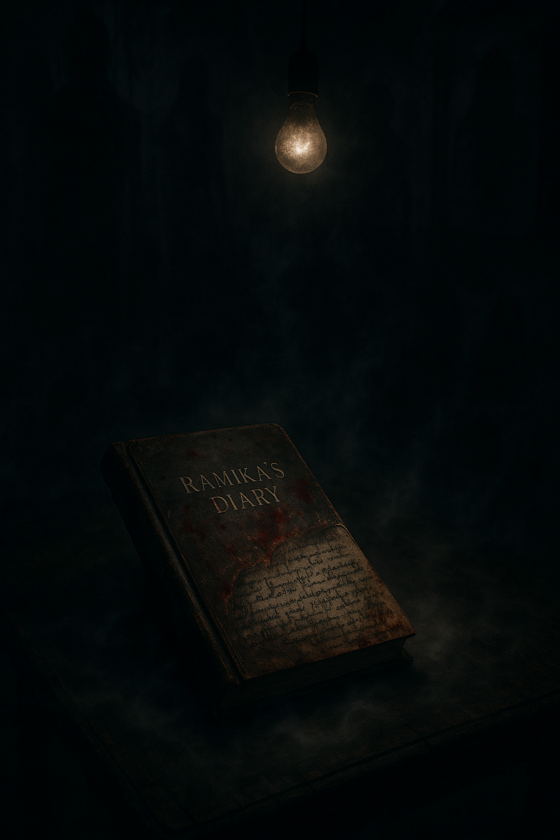

Hariram’s hands trembled slightly.
“Then you should hear it from the start.”

He took a deep breath.
“Ella and Ramika were friends once. Not sisters by blood—but close.”
“Ella married a good man, Ruhan, and they had a daughter—Ruhani.”
“But somewhere along the way, Ella changed.”
“She started getting obsessed… not with her own life, but with Ramika’s.”
“She became jealous. Of Ramika’s home. Her peace. Her husband.”

Hariram’s voice dropped.

“One night, Ella poisoned Ruhan, her own husband.”

“Ruhani saw it all. She was just a child. She watched her father die.
And she watched her mother lie.”

“Ella thought no one knew.”

The Curse Within

Natik clenched his fists.
“So Ruhani’s darkness… it didn’t come from birth?”

Hariram shook his head.
“It came from heartbreak. From betrayal.”
“Ruhani loved her father deeply. After his death, something snapped.
She started learning black magic in secret.
Not to hurt anyone else—but to punish Ella.”
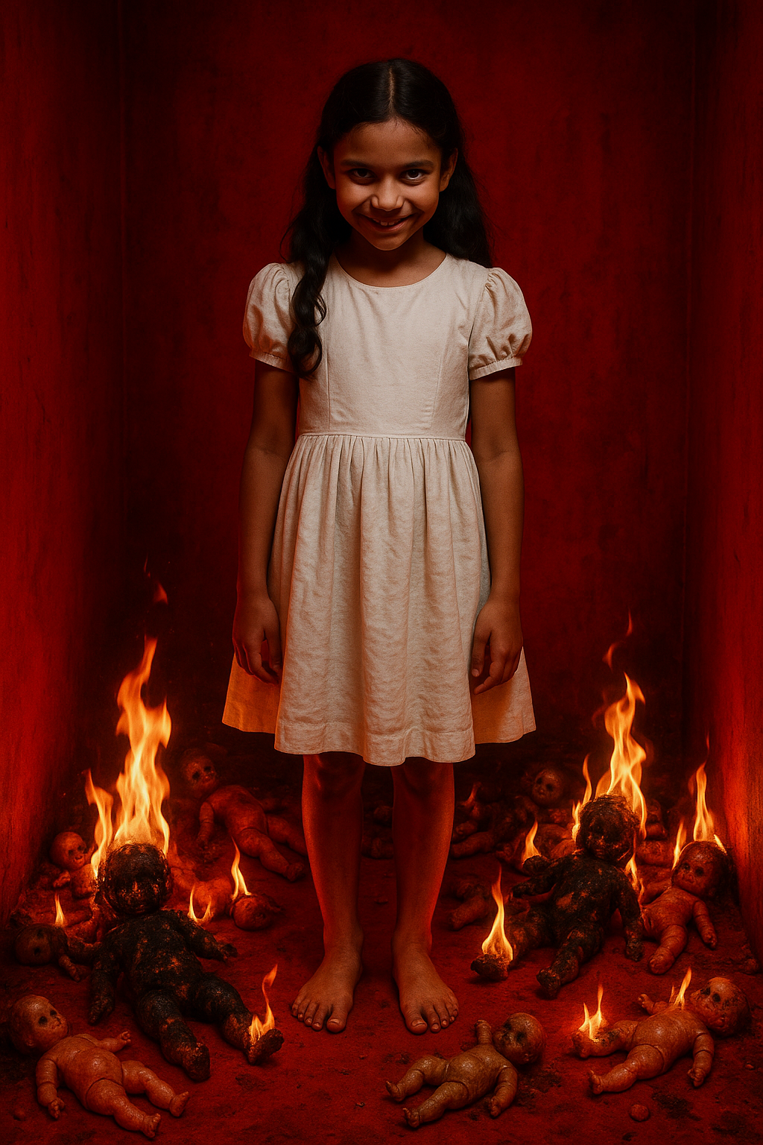
“She cursed her mother slowly.
Not with death… but with madness.”
“Ella began hearing voices. Forgetting who she was.
That’s when she started copying Ramika—her style, her tone, her life.”
“And when the time was right… she killed Ramika too.”

The Living and the Dead

Natik stood up, heart pounding.
“She took everything. Her friend’s life. Her husband. Even Ruhani.”

Hariram nodded.
“Ruhani’s soul was twisted by pain.
And now, she’s using Sarah and Tara to return.”
“But don’t forget—Ruhani is not evil.”
“She’s broken.
And she’s powerful because of what she suffered.”

He leaned forward.
“But if you want to stop Ella…
You need Ruhani.”

Chapter20
Blood Never Lies

Natik reached home after the long journey from Kaala Karva. His mind was restless—filled with Hariram’s half-truths and the photograph he couldn’t forget.

His grandmother sat in the prayer room, humming an old hymn as if nothing had ever happened in the world.He stood quietly, watching her for a moment.

Then— “Dadi… do you know someone named Hariram?”
She paused, then smiled faintly.
“Hariram? No, beta.”
“And Ruhan?” he asked.
Her smile flickered.
“No. Why all these names, Natik?”
“Because I went to Kaala Karva,” he said.

Silence.

Her back stiffened. The incense stick fell from her hand.“You what?” she whispered.And I’ve been to Meher Cottage.

The color drained from her face. Her hands trembled.

“You should never have gone there…”

A Name That Shouldn’t Be Spoken
She stood slowly, her voice cracking.
“Meher Cottage… that house is cursed, Natik.”

“You knew all along,” he said. “You knew Hariram. You knew Ruhan.”

She sank into her chair, breathing heavily.Then, after a long pause:
“Hariram and Ruhan were brothers. I knew them when I was your age.”
“Ruhan married Ella. And Hariram… he never left the village.”
“But the evil didn’t start with Ella. It started with Ella’s mother—Ruhanika.”

The Curse of Ruhanika
Ruhanika wasn’t just a witch. She was obsessed with keeping her bloodline powerful.She believed if Ella never left the land of the cottage, her bloodline would rule the unseen world.

“So she performed a black ritual when Ella was pregnant.”
“That’s why Ruhani was born twisted.
Born in blood. Born at 3:03 am—the same time Ruhan died.”
“Ruhani’s soul was fused with darkness that night.
She can’t be imprisoned… but she can control others.”

“Girls. Innocent girls. She feeds on their minds. Their loneliness.”

Why Hariram Lied

“Hariram didn’t lie to hurt you,” she said, eyes glistening.
“He lied because Ruhani is family. And sometimes, family blinds us.”
“He couldn’t accept the truth—that Ruhani is not broken.
She’s evil. And she enjoys it.”

The Truth About Ella

“Ella was never the victim. She was the chosen one.
Ruhanika trained her in secret, promised her eternal love, eternal youth.”
“But when Ella fell in love with Ramika’s husband…
she poisoned her own Ruhan to make space for more darkness.”
“Ruhani saw it. She punished her mother—with madness.”
And when Ramika tried to stop all this… Ella killed her too.

The Final Bond

“Now Ruhani doesn’t just haunt the house.
She is the house.”
“She won’t let Sarah or Tara go because they remind her of the life she never had.”
“She calls to them. Possesses them.”
“And Ella’s mother still whispers from the walls…
forcing Ella to stay. To carry out the will of the bloodline.”

Natik’s Fate

“But you… you are of the bloodline too,” she said, voice quiet.
“Your father and Ruhan were cousins. That’s why the house let you in.”
“And that’s why you may be the only one who can end this.”
“But if you fail…”

She looked away, trembling.
“You won’t be the only one who’s lost.”

Chapter21
The Price of Truth

Natik’s voice trembled as he sat closer to his grandmother.
“Dadi… who else tried to stop Ella?”

She closed her eyes, as if reliving a buried wound.
“Your father.”

Natik froze.
“What?”

Her voice broke, but she continued.
“Your father knew something was wrong with Ella… with Meher Cottage.
He had seen things. He had felt things no one else could.”
“He went there one night—alone. He thought he could help Ramika…
but he was too late.”

Tears slipped down her wrinkled cheeks.
“He confronted Ella… and she killed him.”

Natik’s heart shattered in silence.
“Why didn’t you ever tell me?” he whispered.
“Because I was afraid. If I told you, I knew… one day you’d go too.”

She placed a trembling hand over his.
“And now you’re in it, Natik.
You carry the same courage as your father. But this house… this curse…
It doesn’t just want your body. It wants your soul.”
If you go back again… don’t go.

Chapter 22
The Final Rites

Grandmother's trembling fingers clasp Natik's hand tightly. Without saying a word, she leads him to that old part of the haveli where no one ever goes. The corridor grows darker with each step, dust dancing in the air like forgotten memories. Natik's heartbeat quickens as they stop in front of a heavy wooden door—faded, locked for years.

She slowly opens it.Grandmother lit a single lamp near the photo of Natik’s father.

Her voice broke as she handed him a copper box filled with sandalwood, sacred ash, and red hibiscus flowers.
“Give their souls peace, Natik…
Ramika, Padma, and Meher.
They deserve freedom—even if we couldn’t protect them in life.”

Natik nodded, his heart heavier than ever.
“And Ruhani?” he asked.

She didn’t answer immediately.
Then quietly:
“You cannot save her.
Only pray… that she doesn’t destroy more.”

The Return to Pari Cottage

Natik crossed the cursed threshold once again.

Pari Cottage was colder now. The walls bled dampness. The mirrors had no reflections.

He carried the box of rites close to his chest and entered the living room, where the three portraits still hung—Ramika’s was cracked, Padma’s faded, and Meher’s eyes seemed to follow him.

He moved to the garden where Padma used to light incense… to the old bathroom mirror where Meher's scream once echoed… and to the basement, where Ramika’s coffin was now sealed.

He performed every rite. He lit the herbs. He whispered their names.

“Padma…
Ramika…
Meher…”

The air grew warm.A gentle breeze stirred the curtains.
For a brief second… peace.

But the peace didn’t last.

Nothing Left to Save

Upstairs, the laughter returned Cold, Empty.He heard Sarah and Tara whispering.

Then Ruhani’s voice—childlike, mocking:
“Too late again, Natik.”

He ran up the stairs.

Sarah stood in the hallway, hair covering her face. Tara sat beside her, carving something into the wall with her nail. Ella’s portrait was missing from the wall. And the entire house felt like it was breathing.

Natik shouted: “Ruhani, let them go!”
Ruhani’s voice came through both girls at once:

“They are me now.
And you… you should’ve stayed away.”

Ghosts of the Living

He turned to flee, but the front door closed on its own.He wasn’t welcome anymore.The house had made its choice.

Padma, Meher, and Ramika’s souls were free now.

But Ella, Ruhani, Sarah, and Tara were no longer living. They were ghosts with a heartbeat.

And the house…

Was theirs forever.
They never left.

Final Title Card

Pari Cottage remains sealed.
But if you hear laughter in the woods…
Don’t answer.

Because the house is never full.
And Ruhani… is still waiting.
Thank you

Thank you for joining me on this dark and thrilling journey.
Your time, imagination, and curiosity mean the world to me.

Every reader who dares to walk these haunted paths keeps the stories alive — and I am grateful for you.

Stay curious, stay brave — and beware of the shadows.
Thank You

To every reader who stepped into the haunted world of Meher Cottage,
Thank you for holding your breath with each turn of the page.
For listening to the whispers in the dark,
For walking beside Natik, Ella, Ruhani, and the forgotten souls of the past.

This story was written with shadows, stitched with secrets,
And powered by your love for horror, mystery, and emotion.

If this tale chilled your spine or touched your heart,
Please consider leaving a review—it means more than you know.

Until we meet again in the next dark corner…

Stay haunted.
Stay curious.
And beware the hour… 3:03.
With fear and gratitude,
Arshita

